Doccumentation for Installation of Cloudera Manager

Step 1:
Type ip address of namenode and port number as below,
For example: 192.168.50.7:7180
Then press enter.
You will see the login page as below screenshot,
give username - admin
password - admin
then press login.
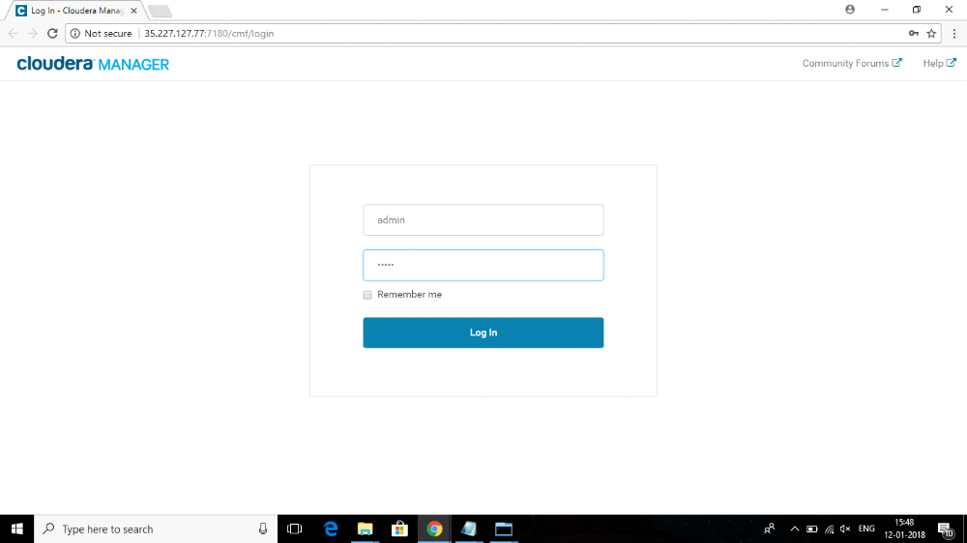

Step 2:
After Logging in, you will see the welcome screen as below.
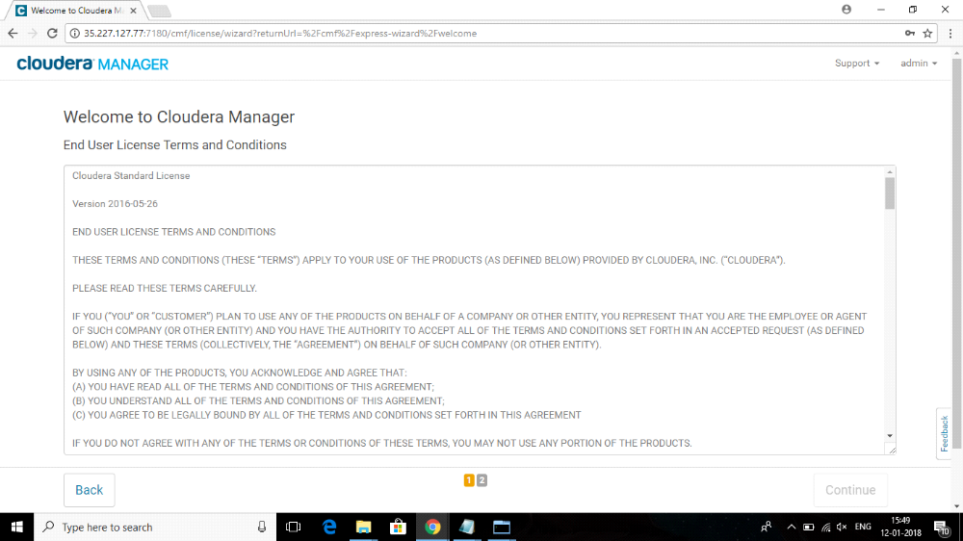

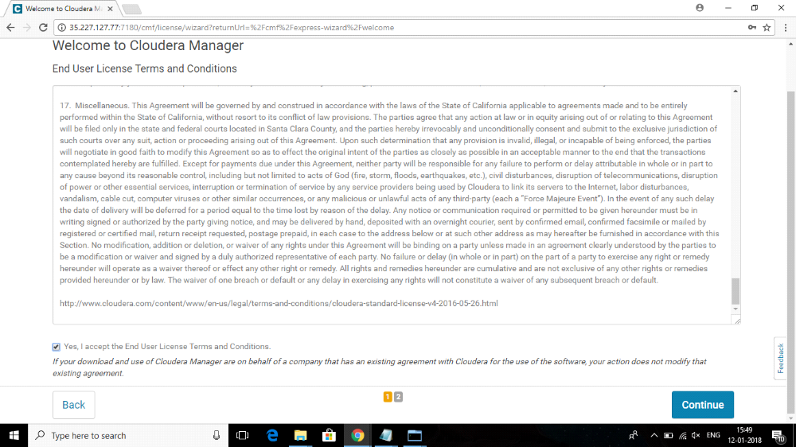

Accept the licence and press continue.

Step 3 :
Here select the cloudera feature by requirement,
Cloudera express is a full time free version
cloudera entreprise trial will give a one month trial for this edition
cloudera entreprise is a full time paid version
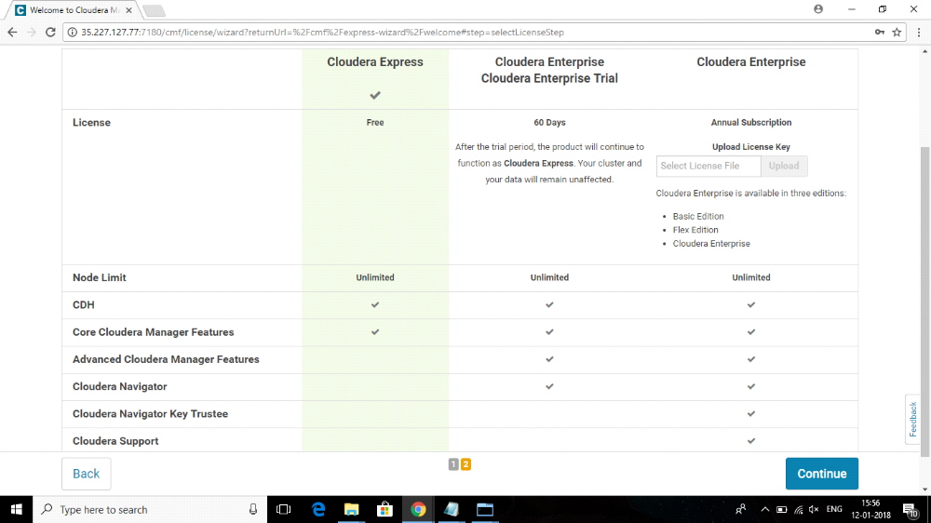

Then press continue
You will get this page
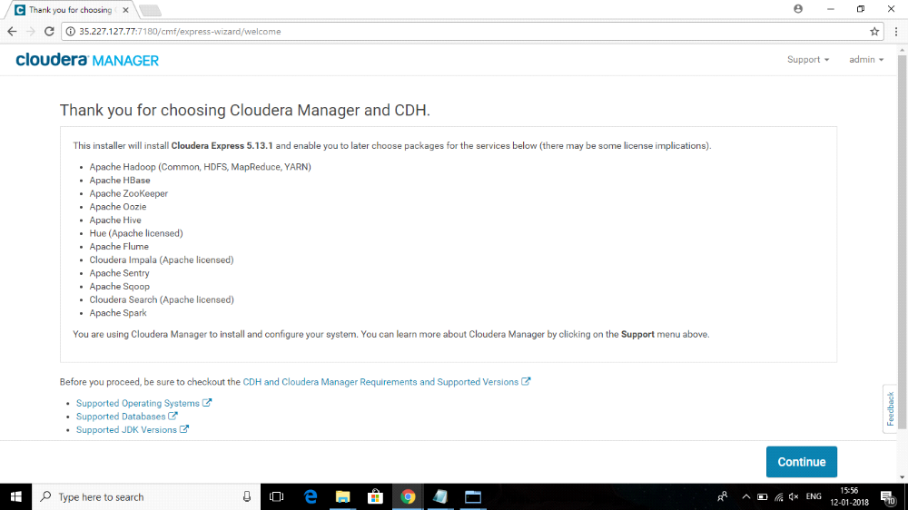
Then press continue agian

Step 4:
Now enter IP address of your nodes in this page and presss search to ping those nodes

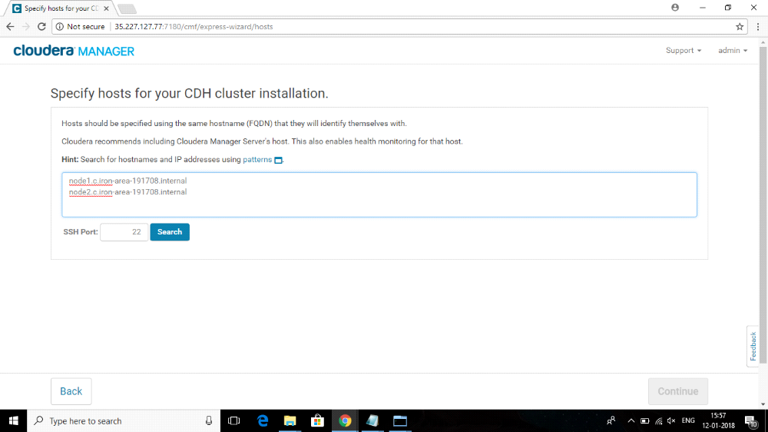
now pick your nodes for cluster installation in the below page
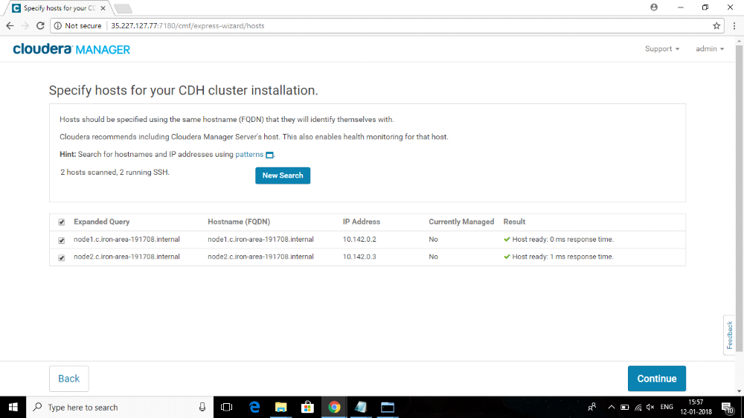

Step 5:
Now select parcels(recommended) method if you are new to cloudera installation.
Then Select the latest version here

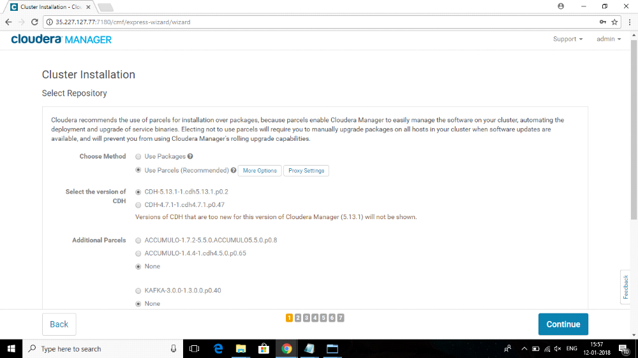

Then select remaining Additional parcels as none
now select the matched release for cloudera manager at last

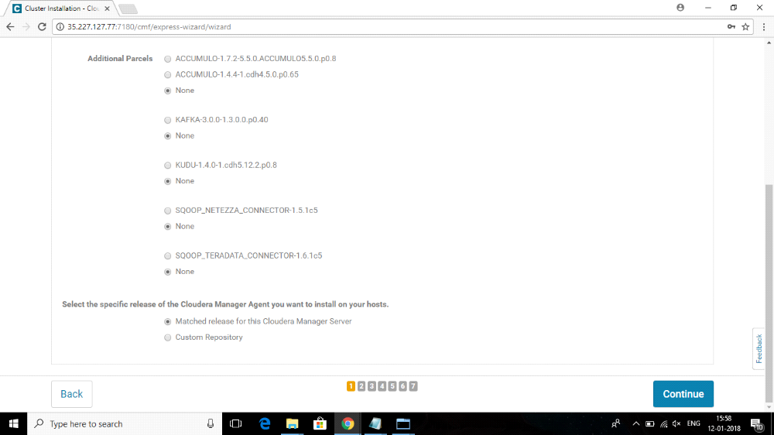

step 6:
Press continue on the next page
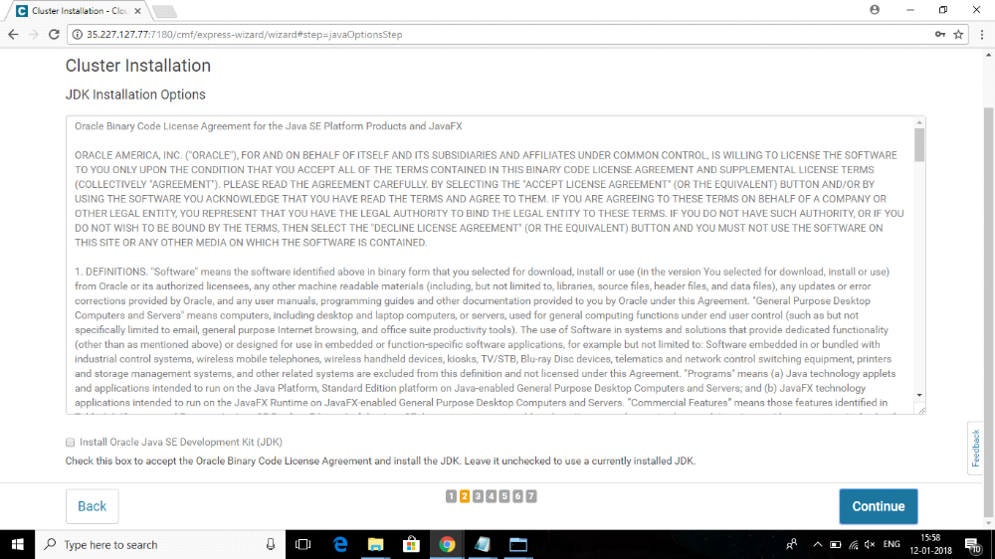

Then select JDK check box
And select encryption policy check box if install kerberos later on your nodes
Then select continue on other pages
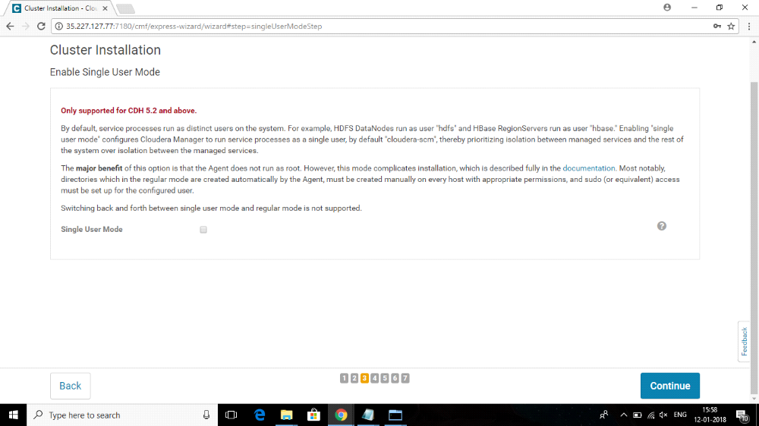
Then the Installation will go on as follows
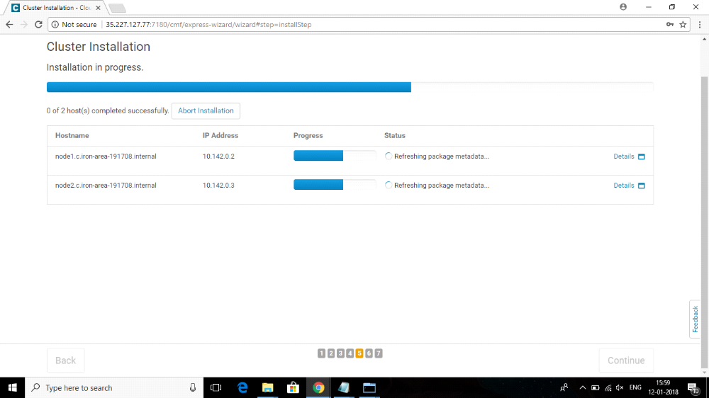
After successfull installation press continue
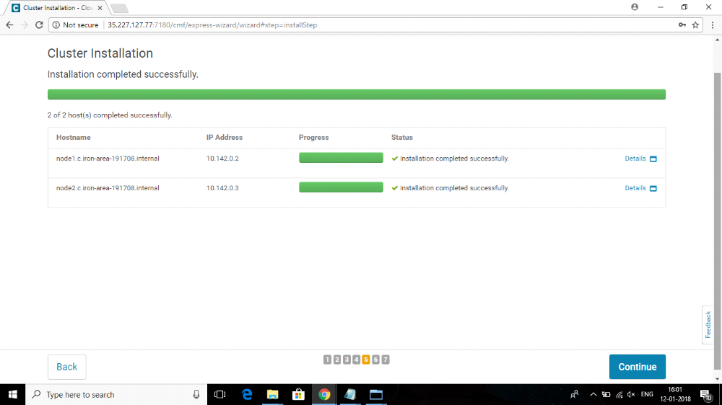
Then parcels will be installed in the next page
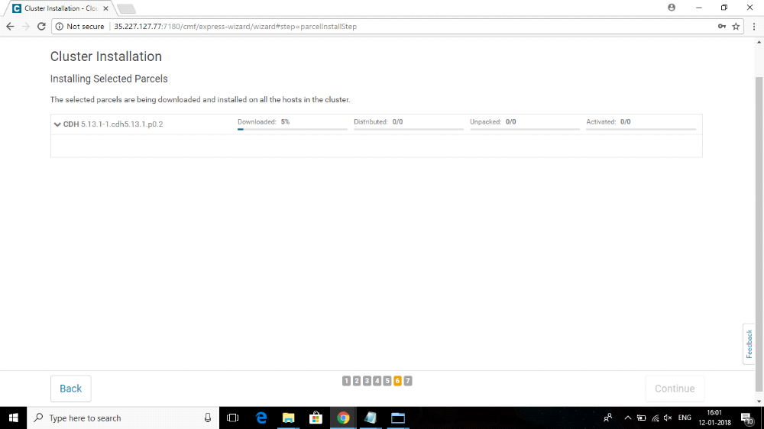
Now you can see the green ticks if the installation was successfull
If you find orange or red symbols there , check the issue in the nodes and do the installation agian
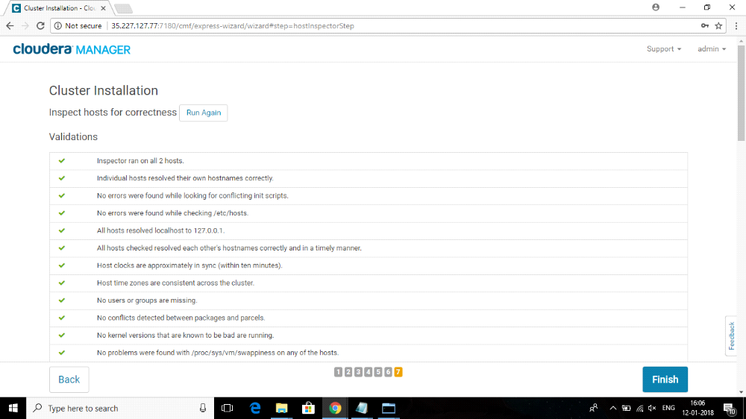
Then press finish

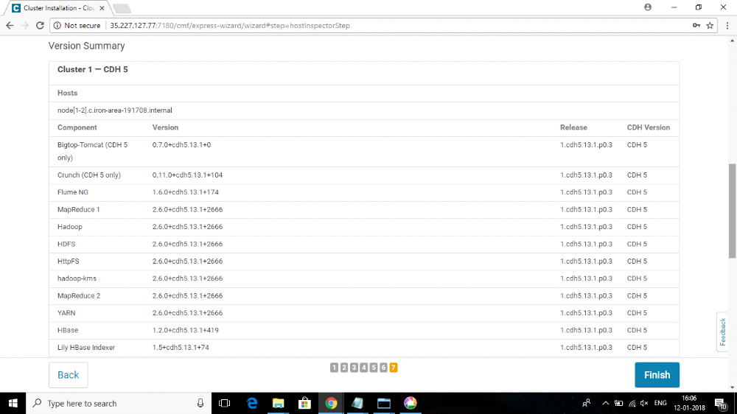
Step 7:
Now in cluster setup process, select All services
if you want a customised one then you can select customed services
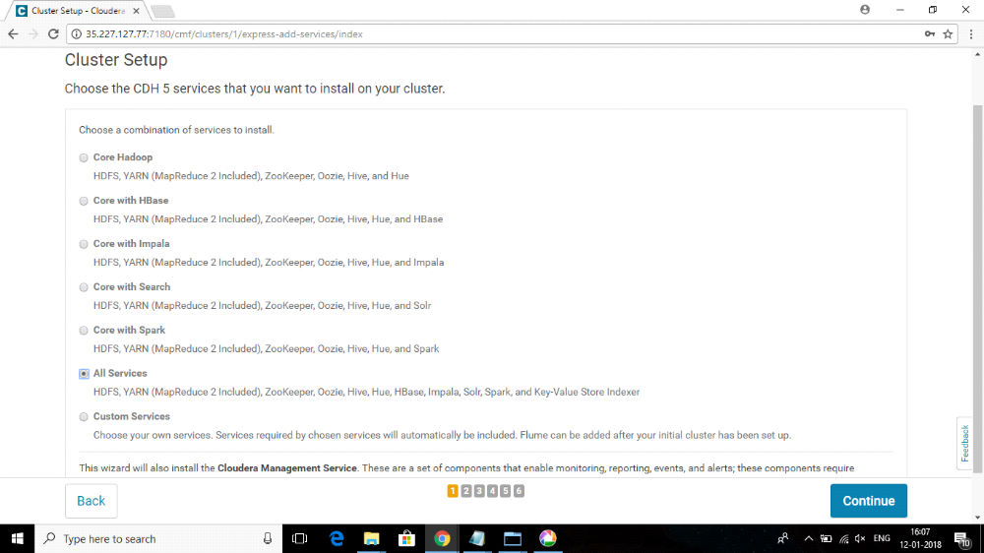

Then you can assign roles in cluster in this page, then press continue
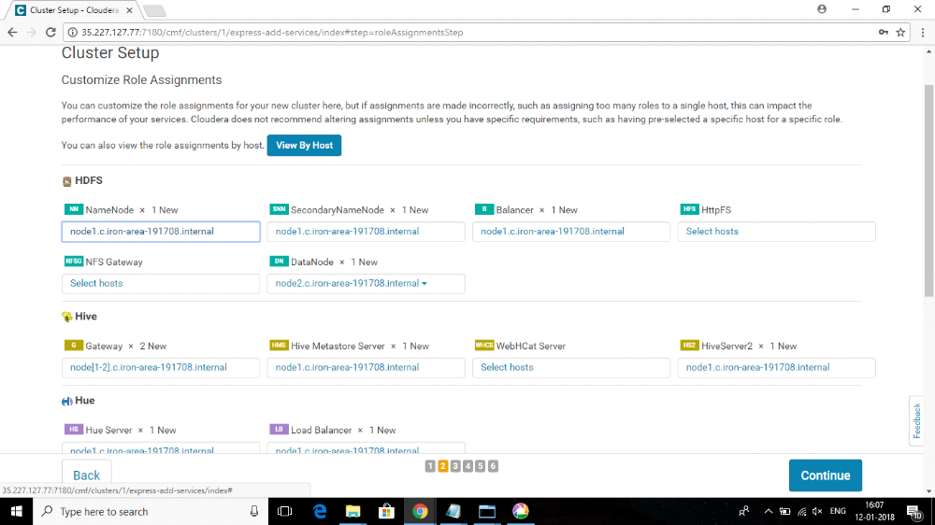

Now select the use embedded database option in this page
Select custom databases option only when you have that requirement
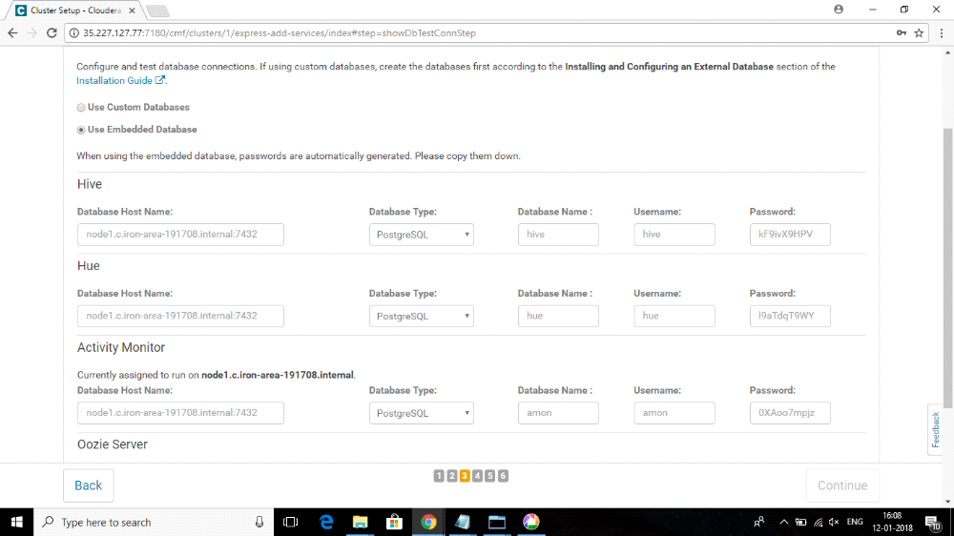
Now put the hdfs block size as 128 then press continue
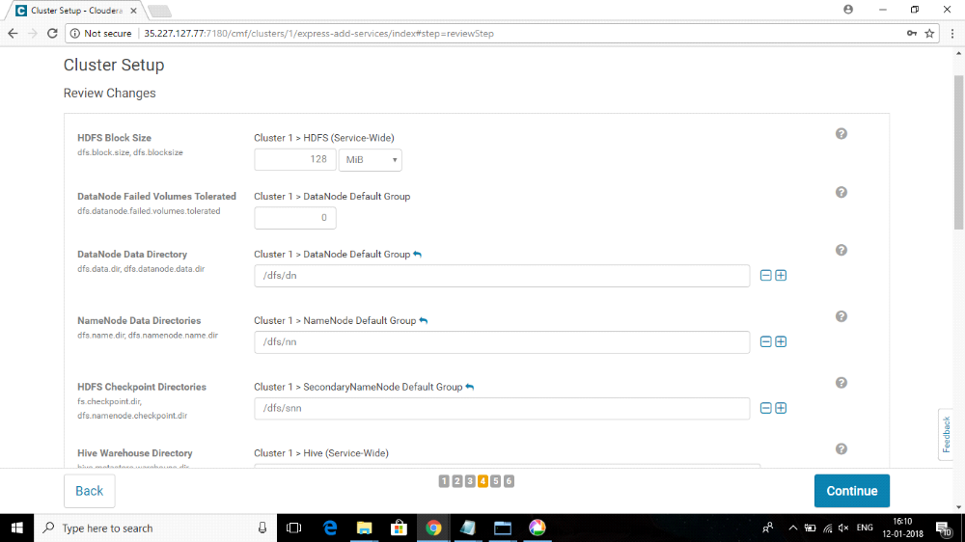

Now you can see the steps completing by selecting show all steps option
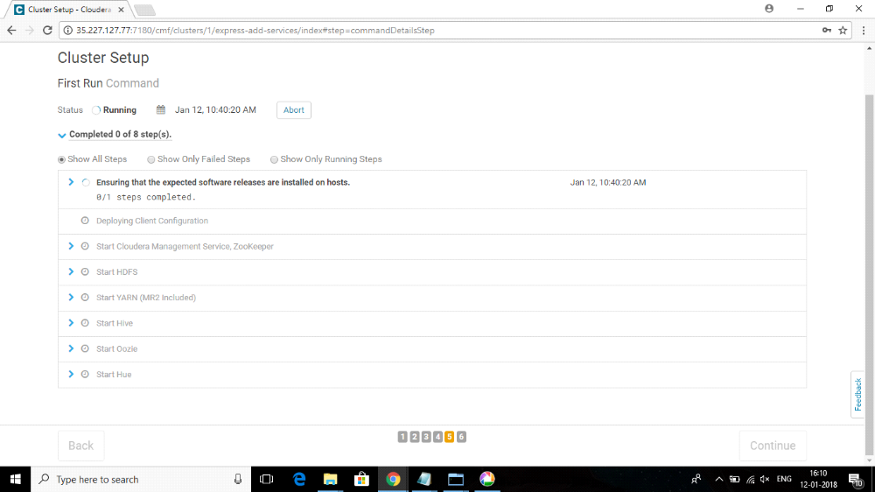

The services are now installed , configured and running on your device if you get congratulations message as below
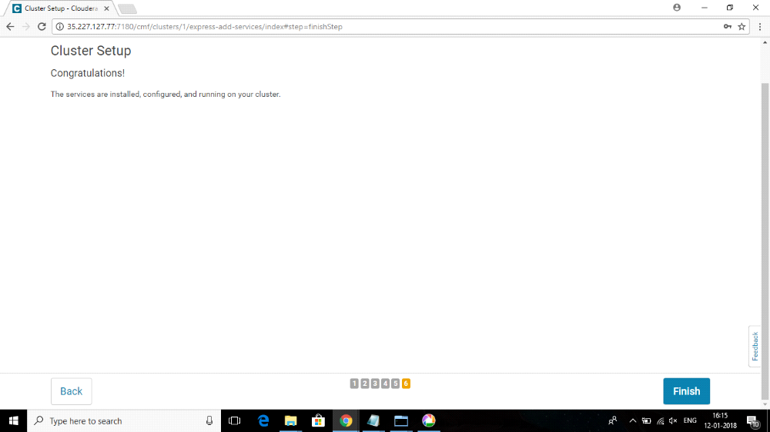
Then you can see the Cloudera manager dashboard as below
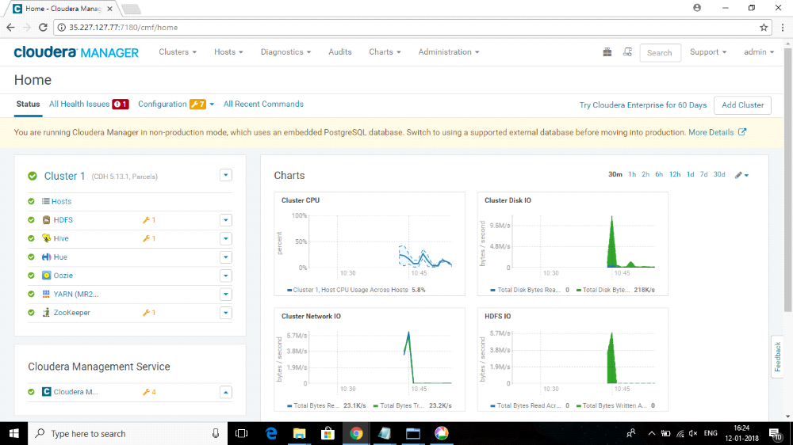

Step 8:
Now if you want to add a service ( for example impala) , select the Add service option and then select impala there
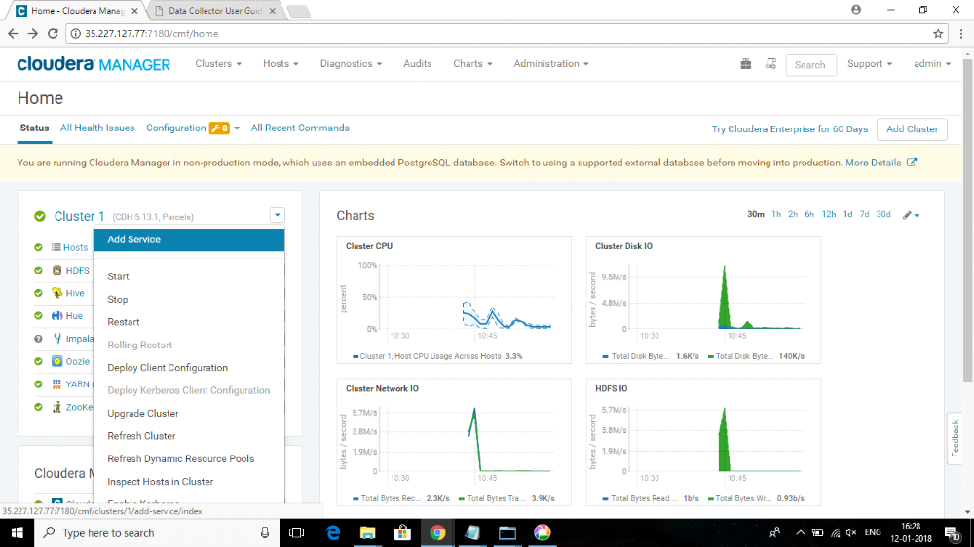
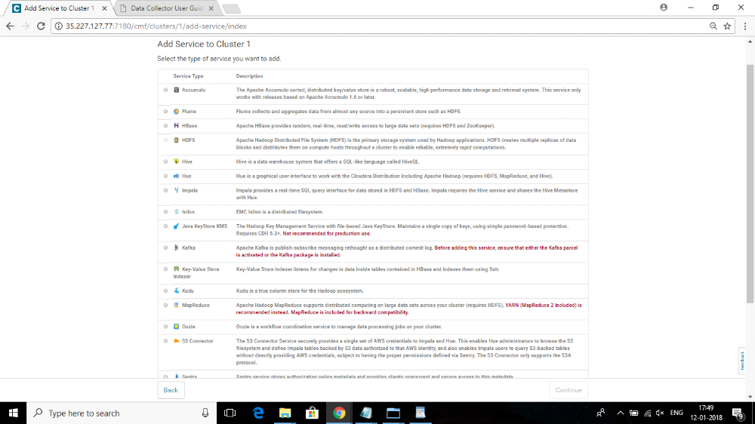

Then select continue
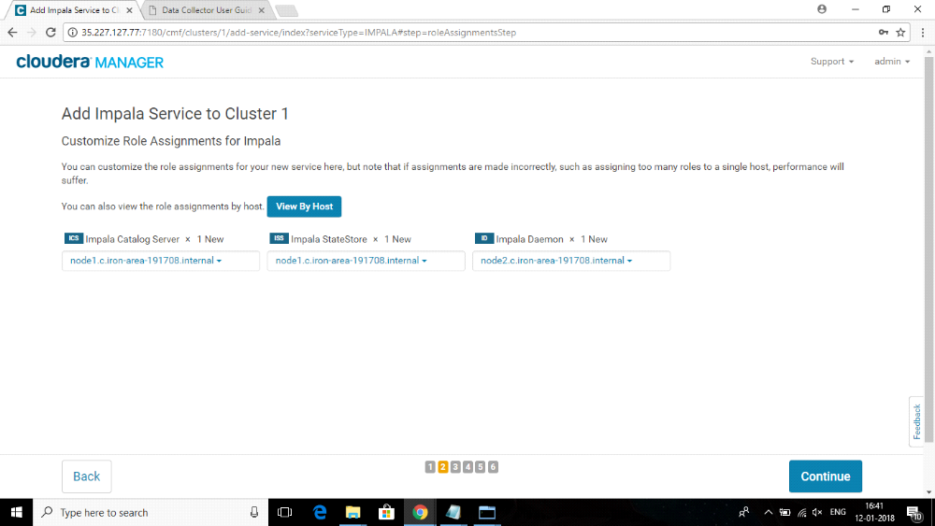
Select continue agian
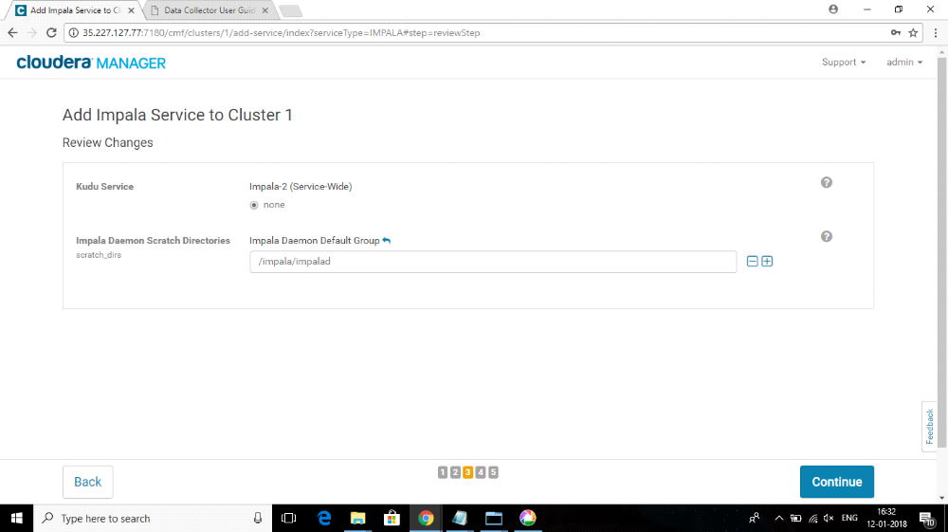
Now you can see it getting installed in steps
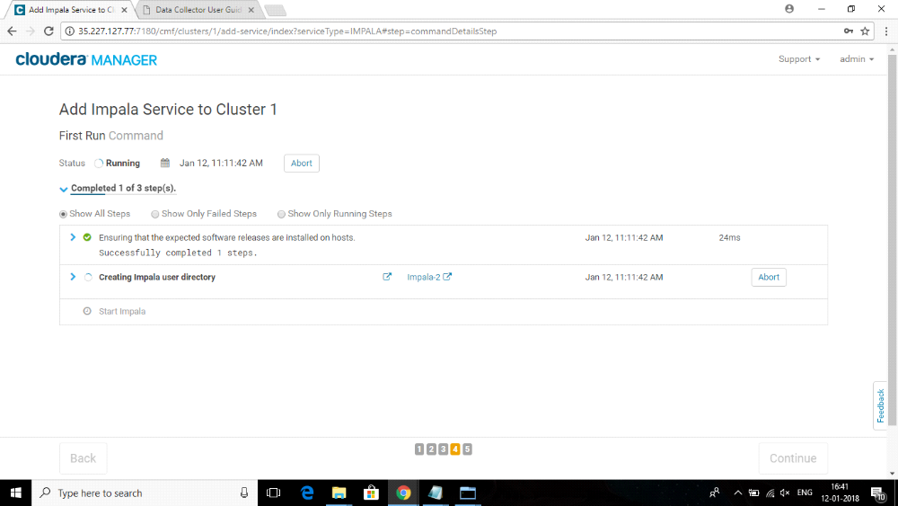
After completion you will see the impala in your services list
